JANET GOLDNER

Groupe Bogolan Kasobané

The Groupe Bogolan Kasobané is an association of six artists from Mali, West Africa: Kandioura Coulibaly, Klètigui Dembélé, Boubacar Doumbia, Souleymane Goro, Baba Fallo Keita, and Néné Thiam. The five men and one woman began working together in 1978. The Groupe is largely responsible for having elevated bogolan, a Malian textile technique traditionally used to decorate garments, to an important symbol of national and even pan-African identity. The members of the Groupe met as students at the Institut National des Arts (L'INA) in Bamako. At that time, bogolan was rarely seen in urban areas and was fabricated only by rural women. The study of bogolan was also strictly forbidden at the art academy. The Groupe's use of local materials and elevation of materials associated with craft is a strategy employed by many contemporary artists throughout the world. Their first objective, to promote and perserve bogolan and to have it accepted and valued as artistic expression has been achieved. The Groupe moved the technique from craftsmanship to art. Today the Groupe is known because of their numerous exhibitions in Mali and around the world. Working collaboratively and developing new approaches to this centuries’-old technique, they have continued to feature it in their art and award-winning costume and set designs for film and stage as well as fabrics for fashion and home furnishings.

It was Kandioura Coulibaly who rallied the five other like-minded artists, and they all fought to employ bogolan in their paintings as a way to reference their Malian heritage. The Groupe abandoned modern painting methods, which formed the curriculum at L'INA, in favour of the traditional technique of bogolan. Western art materials were and are very expensive in Mali. Paint, paper, brushes and other materials have to be imported from Europe. This pushed the Groupe to use the traditional art materials which exist in Mali, vegetal pigments such as clay and plant dyes on locally grown, hand-woven cotton cloth.

The traditional Bogolan textile technique employs a clay slip with a high iron content, found on certain riverbanks throughout Mali, to produce black designs on hand-spun, hand-woven cotton cloth. The clay is applied directly to the cloth using such implements as a quill, stick or brush. Other colors are achieved from the use of vegetal dyes, which come from different species of local plants and result in colours that range from ochre, to khaki, to reddish brown. Bogolan is often translated as "mud-cloth". This is inaccurate since the black pigment is produced by a clay slip and no mud is involved in the process.

After graduating from L’INA, members of the Groupe traveled throughout Mali to research the traditions and practices of bogolan. The Groupe's most important findings had to do with the symbolic alphabet, the traditional structure and uses, and the meanings of the traditional colors encoded in the bogolan cloths used as skirts by women. This information enabled the Groupe to read the significance and the teachings of the cloths which were in danger of being lost.

More recently, the Groupe has worked on a body of work, which the artists call "Gauffrage" or waffle. It is inspired by another Malian textile technique used to make the protective hats of Malian hunters. Cotton hats are stuffed and made into helmets to protect the heads of the hunters whose work takes them into the countryside where there are snakes, thorns, trees and animals.

The Groupe is working on the larger project that engages many African intellectuals these days, of reconstructing, uncovering and, researching what is hidden under the history of Africa as it has been written. They are concerned with preserving and perpetuating the cultural heritage of Mali, which is in danger of being lost because of the cultural disruption and erasure that resulted from colonialism. Their contribution is their ability to interpret the stories that are told by the material culture that remains.

The art of the Groupe Bogolan Kasobané is inspired by the context in which the work is conceived and elaborated. It is the consequence of a collective inspiration, the joy of the work and is rooted in the community tradition of Malian society. It is this intimate and specific connection to Malian culture that distinguishes the art of the Groupe. The work blooms in the symbiosis of traditional and contemporary art.

The Groupe's work is layered with meanings some of which are universal and others of which are culturally specific. The Groupe explores a visual language of symbols through the rescuing, invention and juxtaposition of Malian symbols. Even without knowing the significance of the symbols, the works hold as paintings. An understanding of Malian history and culture adds to the work.

Although the members of the Groupe were formally trained in art, and know and admire the works of the major artists of the world, their originality has been in their refusal of European painting techniques: the easel, perspective, chemical colors and all other external elements in favor of the ancestral ways of representation. Using dyes as paint, the innovation within the bogolan tradition is realised in the allegorical narrative compositions, the graphic style, the expanded palette and in the presentation of works as stretched canvases. Their singularity, as contemporary artists, has been to develop a responsible artistic conscience in the face of social turbulence. The bogolan canvas is a mosaic of fantasy and reality, encompassing a proverb, a legend, a grand theme or a real situation. The bands of cotton woven by the ancestors, drawn by contemporary artists, are a point of connection for tradition and an imagined future.

References and Further Reading:

Doumbia, Boubacar & Groupe Bogolan Kasobane, http://www.ndomo.net/english/

Goldner, Janet (2010) Contemporary African Fashion, Indiana University Press, 105-122.

Goldner, Janet, http://www.janetgoldner.com/projects/groupe-bogolan-kasobane/

Groupe Kasobane (2006) L’Evolution des Teintes Naturelles, Groupe Bogolan Kasobane.

Rovine, Victoria L (2001) Bogolan: Shaping Culture through Cloth, Smithsonian.

Images for Groupe Bogolan Kasobané
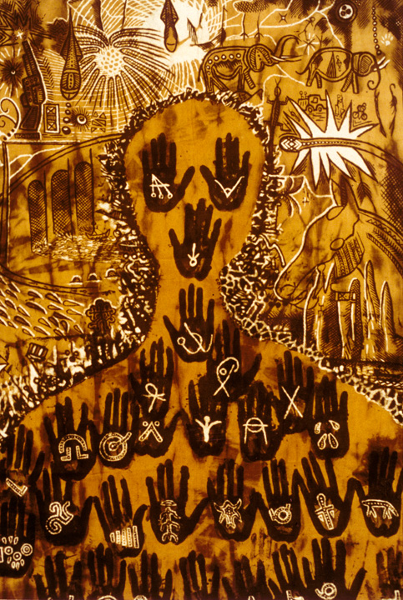
Image 1: Groupe Bogolan Kasobane, Man is a Dangerous Animal, bogolan painting (cotton cloth painted with bogolan materials)

Copyright holder: Janet Goldner (entry author)

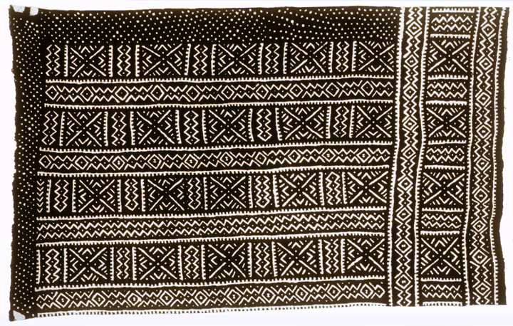
Image 2: An example of a traditional bogolan cloth. This technique serves as the inspiration for the work of the Groupe.

Copyright holder: Janet Goldner (entry author)

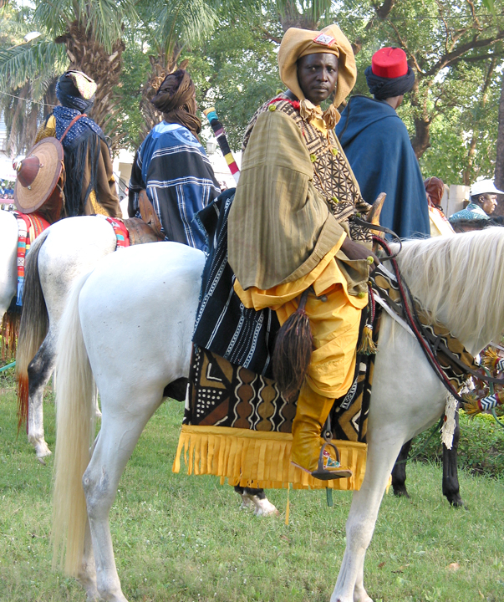
Image 3 Jockey in bogolan costume Photo by Janet Goldber

An example of more recent work of the Groupe Bogolan Kasobane which is part of their work of cultural preservation.
Copyright holder: Janet Goldner (entry author)

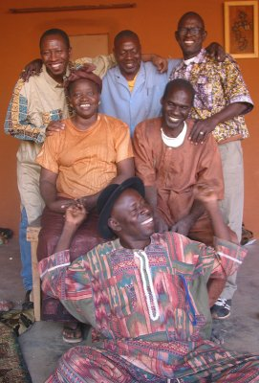

Image 4 Groupe Members
Link To Material : Goldner, Janet, http://www.janetgoldner.com/projects/groupe-bogolan-kasobane/

Bibliographic details: photo by Janet Goldner

Copyright holder: Janet Goldner

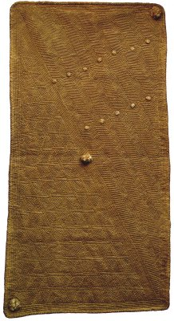
Image 5 Groupe Bogolan Kasobane, Plants in the Garden, gauffrage

Bibliographic details:

Copyright holder: Janet Goldner

